Actuaries’ Club of Hartford & Springfield
November 10th, 2022, Connecticut Convention Center
8:00 – 9:00  9:00 – 9:15 | Registration & Continental Breakfast  Welcome from the Club President | Ballroom B Foyer Ballroom B
9:15 – 10:15 | C-Suite Communications  Jen Healy, Chief of Staff for Individual Markets, Global Atlantic  David Weinsier Partner & US Insurance Practice Leader, Oliver Wyman  Tom Buckingham Chief Growth Officer, Nassau Financial Group  Matt Condos Senior Vice President, Lincoln Financial | Ballroom B
10:15 – 10:45 | Refreshment Break | Ballroom B Foyer
10:45 – 11:45 | The Inflation Reduction Act: What’s Changing in Healthcare? | Meeting Room 13
Kevin Pierce Consulting Actuary, Milliman
Hiram Satterwhite Senior Consulting Actuary, Milliman
Climate Risk – Are You Ready? Meeting Room 12
Mark Mennemeyer Director, WTW
Tinashe Masaya AVP, Voya Financial
LDTI – Key ‘Day-1’ Roadblocks That Could Derail Your Journey Meeting Room 15
Daniel Jonas Manager, Ernst & Young
Joe Szewczyk Senior Consultant, Ernst & Young
Experiences from Entrepreneurs Meeting Room 11
Cheryl Poulin Private Contractor
Chris Amon Founder & Owner, Amon & Associates
Brent Walder Speaker, Executive Coach, & Leadership Developer
Matt Condos Senior Vice President, Lincoln Financial
Pricing and Marketing: Give and Take of Profitability with Competitiveness Meeting Room 14
Chris Hancock Annuity Pricing Product Lead, Nassau Financial Group
Anthony LaRosa Annuity Marketing Director, Nassau Financial Group
11:45 – 1:00 | Lunch & Club Business Meeting | Ballroom B
1:00 – 1:15 | Break
1:15 – 2:15 | Data Science in Action | Meeting Room 15
Kevin Northover Lead Data Scientist, Delta Dental of New Jersey
Economics of Bermuda Captives and Sidecars Meeting Room 13
Don Cho Senior Manager, Ernst & Young
The Trial of Frederick L. Hoffman: A Precept 1 Case Study Meeting Room 14
Jay M. Jaffe President, Actuarial Enterprises, Ltd.
2:15 – 2:30 | Break | Ballroom B Foyer
2:30 – 3:30 | The Wild and Fast Paced World of Stop Loss and Large Claims | Meeting Room 13
Jon Forster Chief Operating Officer, Medical Risk Managers
The End of an Era? Inflation and the (Potential) End of Low Rates Meeting Room 15
Jim Kosinski Head of Market Risk, Talcott Resolution
Cooper Woodruff Assistant Portfolio Manager, Talcott Resolution
Forensic Actuarial Consulting Meeting Room 12
Anthony H. Riccardi Forensic Actuary
Market Volatility – Impact on Retirement Plan Management Meeting Room 11
Sarah Rothenberg Director & Consulting Actuary, Empower
Tom Harrigan Director & Consulting Actuary, Empower
David Pappalardo VP & Consulting Actuary, Empower
Examining Bias Through the Model Development Lifecycle Meeting Room 14
Mark Sayre Law Student, University of Maine
Andrew Reagan Lead Data Scientist, MassMutual
3:30 – 4:00 | Refreshment Break | Ballroom B Foyer
4:00 – 5:00 | Practical Applications of Data Science for Actuaries | Ballroom B
 | Jackson Lautier Ph.D. Candidate, Department of Statistics – University of Connecticut
5:00 – 6:30 Sponsored Networking Reception (redeem drink ticket at cash bar) Ballroom B Foyer
ACHS CLUB OFFICERS:
President – Rachel Spitzig | Vice President – Tinashe Masaya | Secretary – Jerrick Zhang | Treasurer – Jeff Roscoe
ACHS PLANNING COMMITTEE:

Henry Collie
Rob Tavernier
Audrey Comisky
Alex Granovsky
Neil Kelsey
Chris Lockhart Adeniyi Olaiya Ruth Nieh
SAVE THE DATE FOR OUR NEXT MEETING: TUESDAY, May 16TH, 2023

Brian Thibeault
Krista Weber
Matt Condos
Quinn Cahill
David Reynolds
Joe Finch
Andy King
Jeremy Lamontagne
John Golemba
Thank You to All of Our Sponsors!

Silver

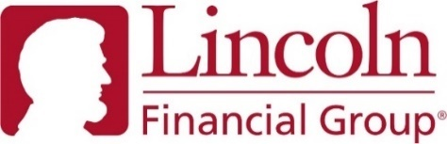
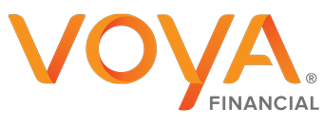

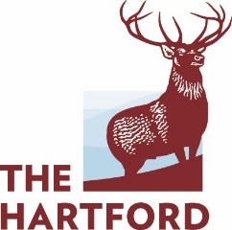

Bronze

Gold

